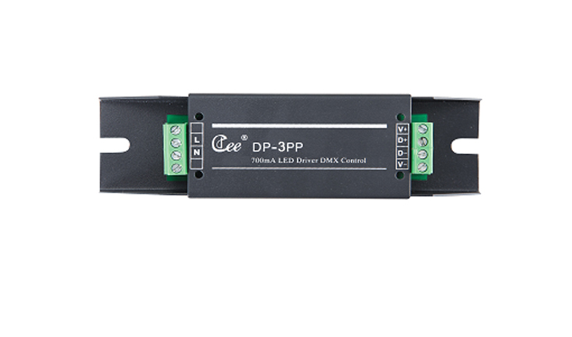

CEE DP-3PP

Function and performance:
Adjustable light LED constant current drive output, single-channel maximum current of 350 mA / 700 mA.
110-240V 50-60Hz AC voltage input.
Standard DMX512 signal control (1990).
More than 1024 high-precision dimmer.
More than 2 KHz high refresh rate.

